**Symbiosis Institute of Technology, Nagpur**



**Computer Science and Engineering Batch 2022-26**

**Course Name: Compiler Construction Lab**

**Name: Sujal Junghare**

**PRN: 22070521089**

**Division: C**

**Department: CSE**

**Semester-VII**

**Course Code: T7478**

1. **Theory assignment for writing details about LEX and YACC compilation.**

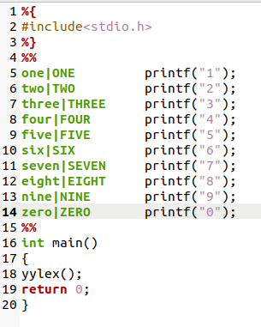

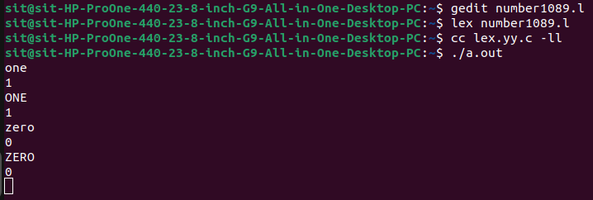

1. **Count the number of comments, keywords, identifiers, words, lines and spaces from input file.**

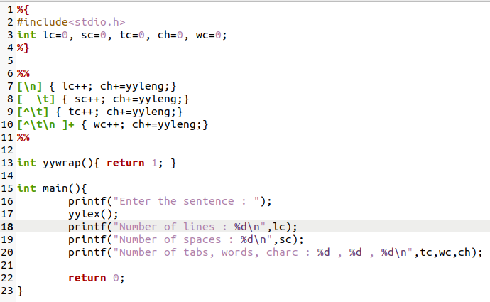

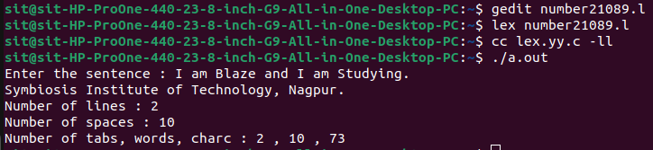

1. **Count number of words starting with 'A'.**

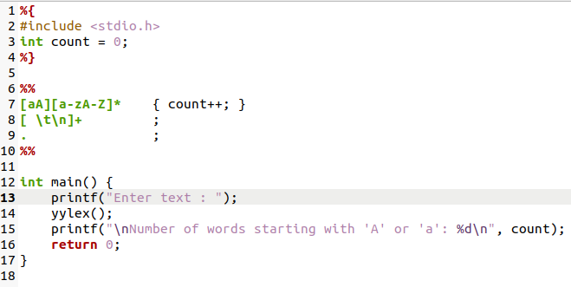

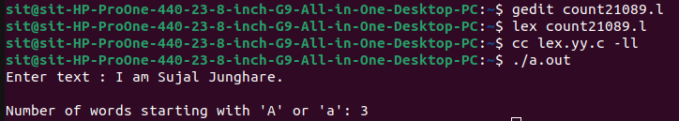

1. **Conversion of lowercase to uppercase and vice versa.**

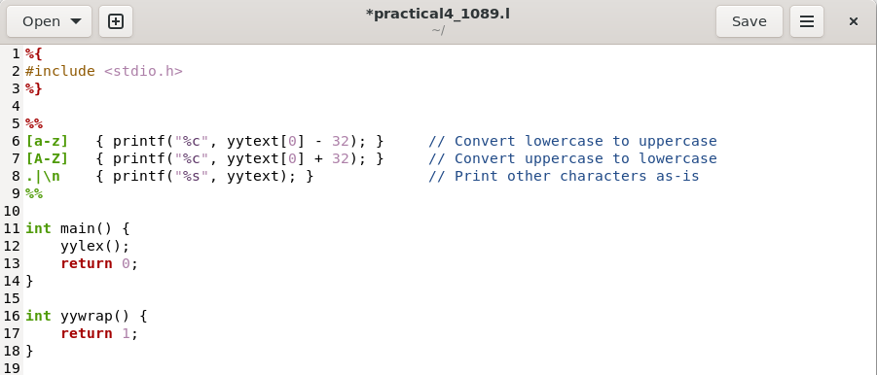

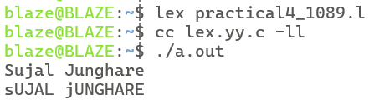

1. **Conversion of decimal to hexadecimal number in a file.**

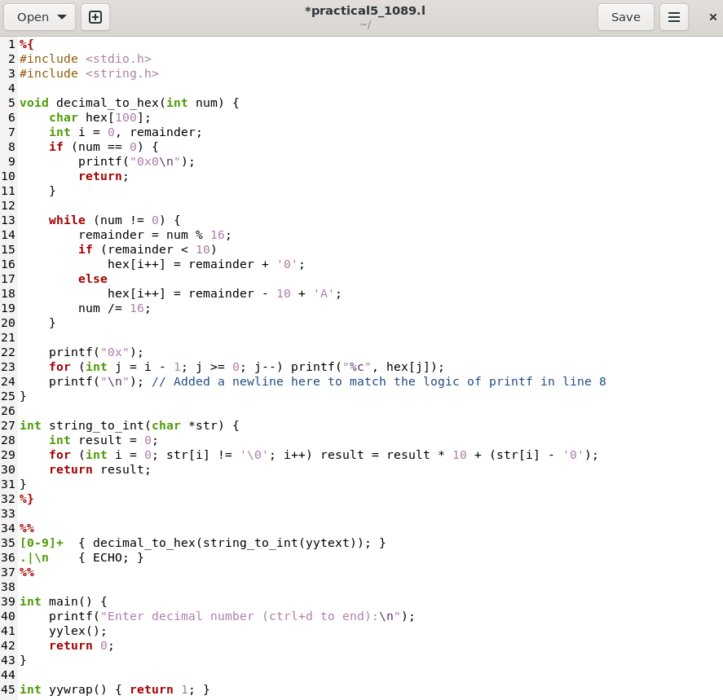

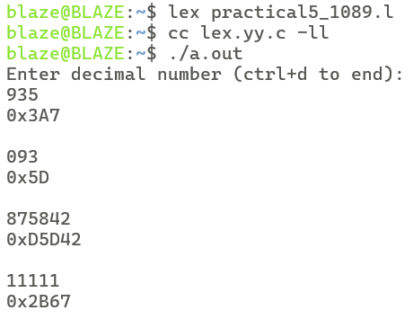

1. **Test lines ending with ''com''.**

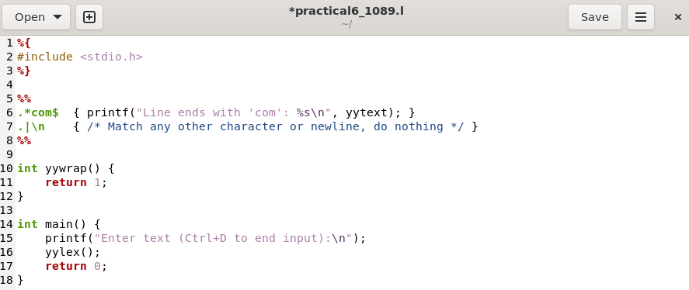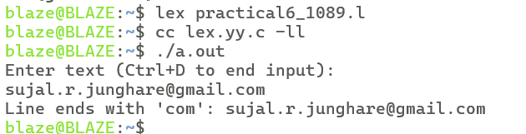

1. **Postfix Expression Evaluation.**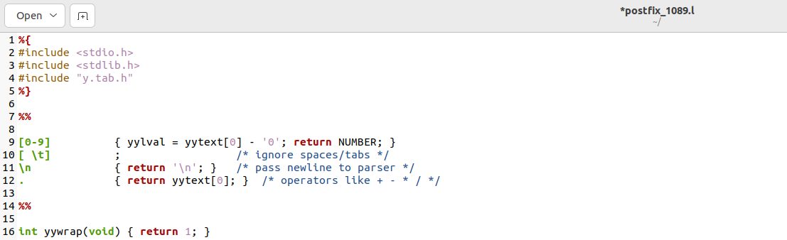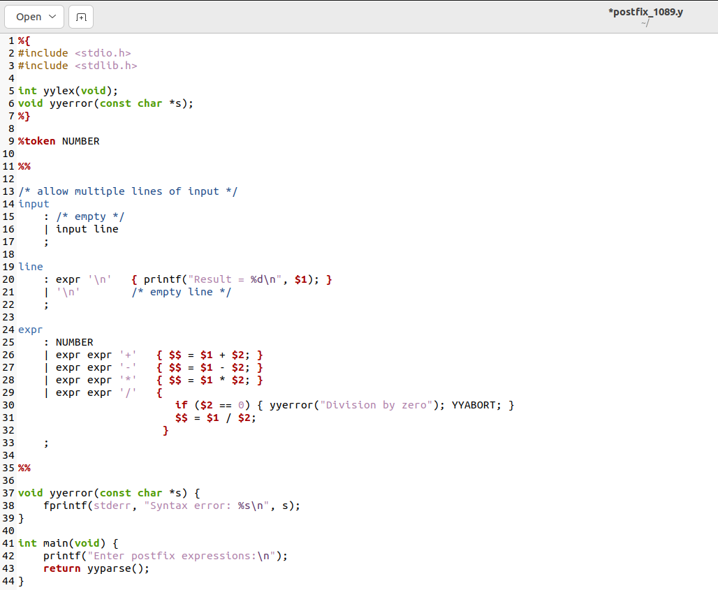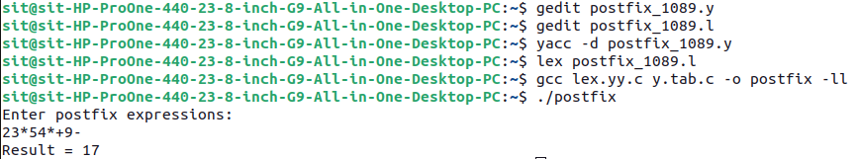
2. **Desk calculator with error recovery.**

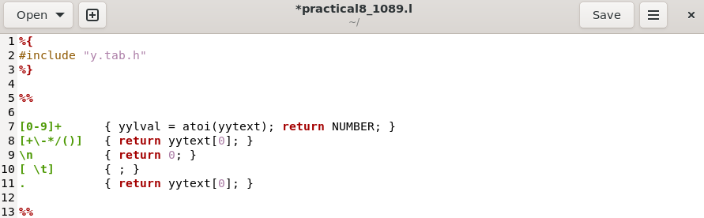

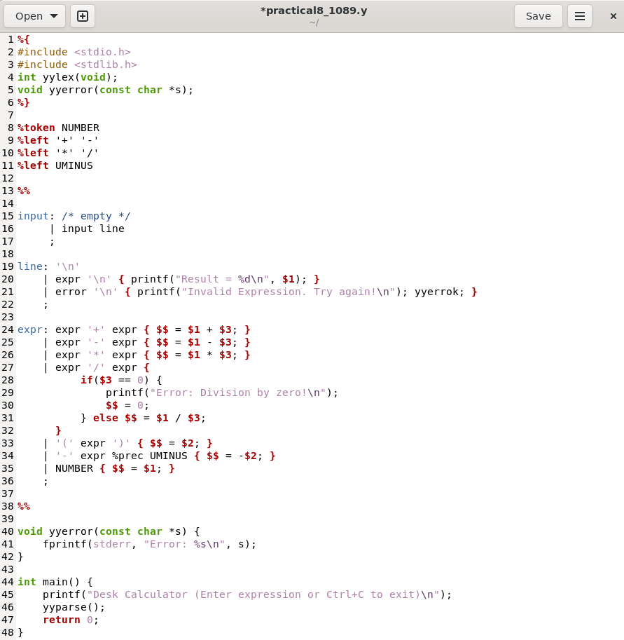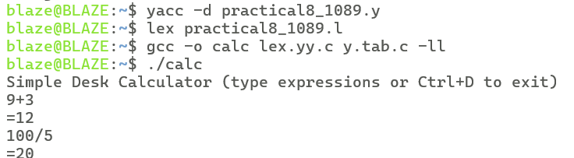

1. **Parser for ''FOR'' loop statements.**

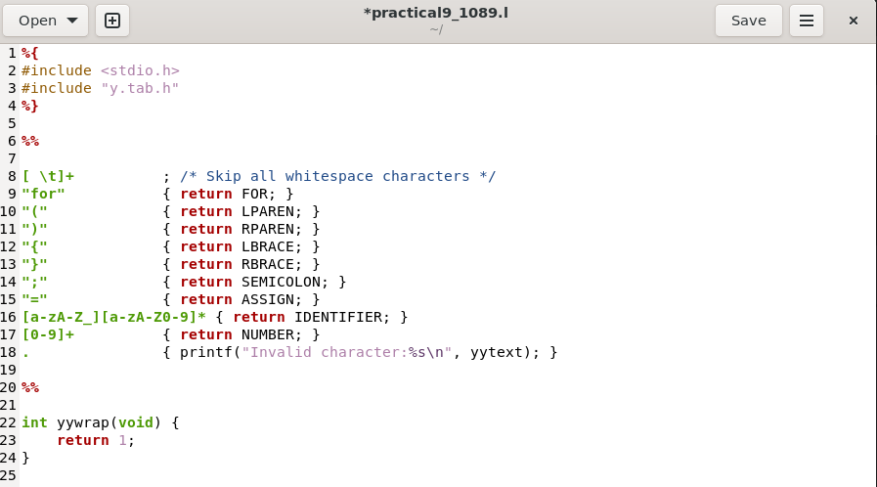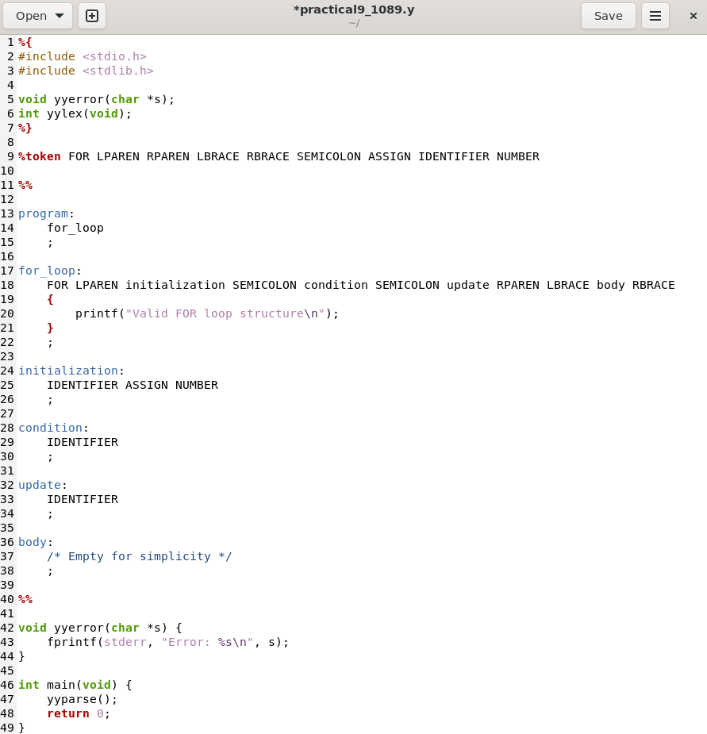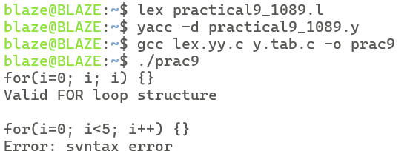

1. **Intermediate code (IC) generator for arithmetic expression.**

